PORTARLINGTON BUSINESS DEVELOPMENT ASSOCIATION INC.
Association registration number A0047889R

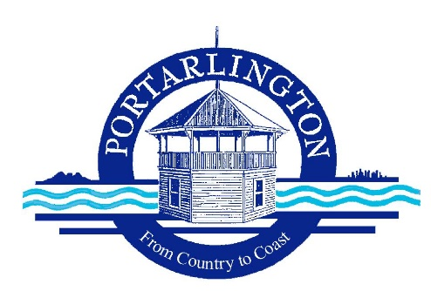

Hi to all PBDA Members I would like to let you know that I will be standing down as the President of the PBDA at our April meeting.

I would like to thank the members of the Executive for all of their support and of course our amazing members and their contributions most being through their Businesses to our community.

Lee and I have decided to move to WA after the sale of Hive in the Margaret River Region with the arrival in June of a new Grand Child and I will be pursuing some business opportunities.

I wish you all success in the future.

Mark Williams from the Post Office has agreed to stand in as the Interim President until the AGM later this year I have no doubt Mark will do a great job.

Yours sincerely,

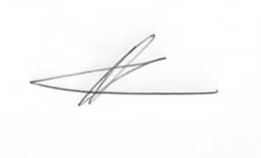
Ashley Andrew
President PBDA 0437530773

